**BEEE Phase 1 Project**

Circuit Diagram

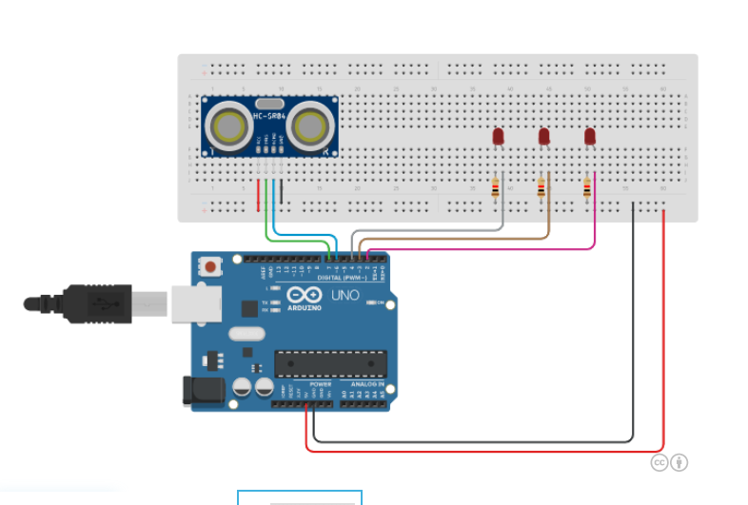

**Hardware required –**

1.Arduino UNO

2.wires

3.Ultasonic distance sensors

4.Breadboard

5. 3 resistors

6. 3 LED’S

**Theory** – Using Arduino UNO which is a microcontroller board based on the ATmega328P and ultrasonic sensor, we can create an automatic almirah which automatically turn ON the LED’s when opened. The Ultrasonic sensor works on the principle of sending and receiving ultrasonic waves.

**How it works**

When we open the almirah the ultrasonic sensors Using Arduino UNO automatically turn ON the 3 LED’s as it is already programmed for that if it receives the wave upto 90cm the LED’s will glow…Otherwise Not.

**Precautions** – 1. Write the code correctly.

2. DO wiring properly.

Must use resistors along with LED’S.

**CODE -**

